# Manual Test Plan

# Page 2: Initial Map

# Page 3: Zoom In

# Page 4: Satellite View

# Page 5: Full Screen

# Page 6: Current Location

# Page 7: Pantry Location

# Page 8: Street View

# Page 9: Pre-Filled Information

# Page 10: Auto-Fill Destination

# Page 11: Route Map

# Page 12: Quotes

# Page 13: Auto-Fill Personal Information

# Page 14: No Initial Stats

# Page 15: Added 1 Stat, 2 Stats, 3 Stats

# Page 16: Past Route Information

# Initial Page

This is the home map screen centered around our current location (Siebel Center) showing nearby Food Pantries and places that accept food donations.

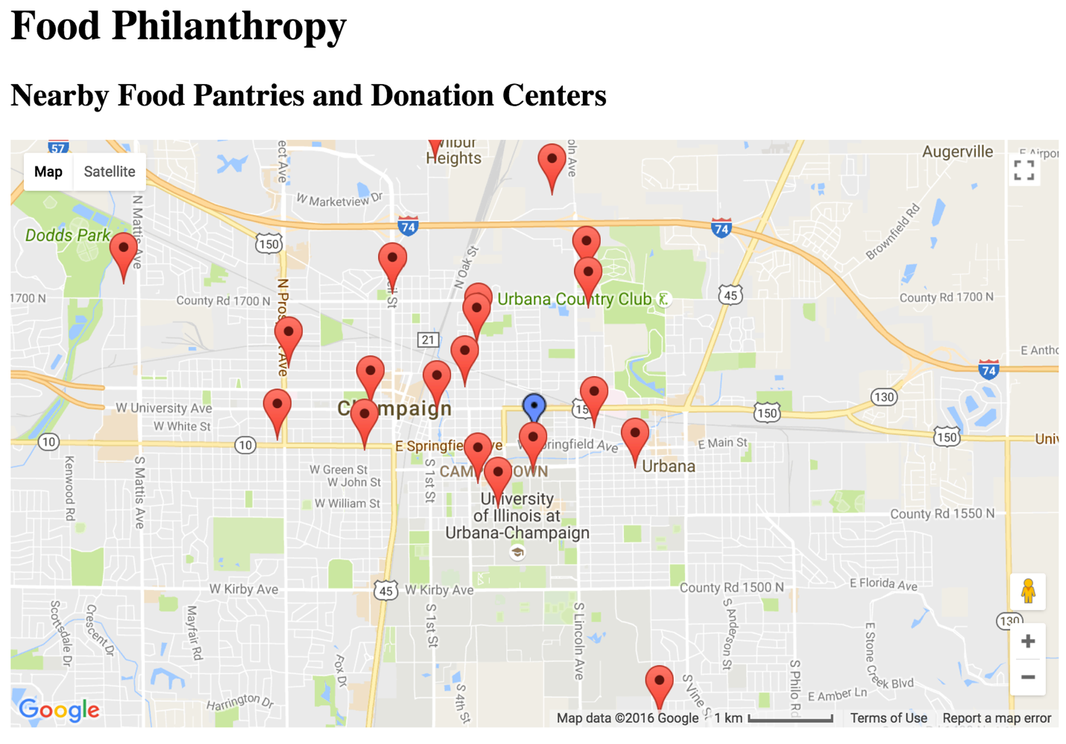

# Zoom In

This provides an example of zooming in to the screen to show a closer view of nearby pantries based on current location.

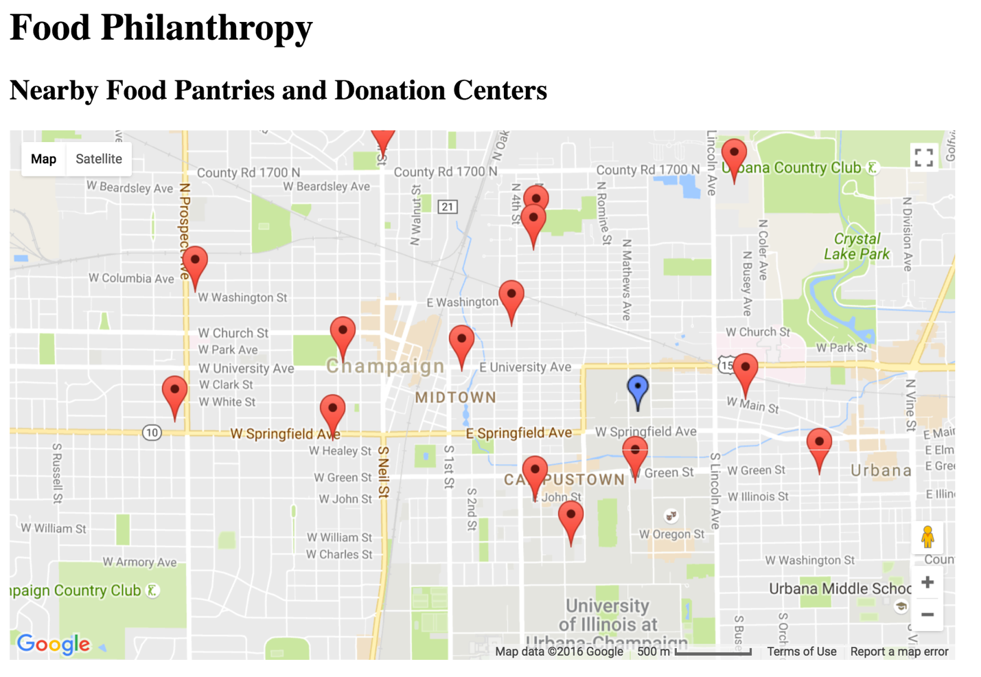

# Satellite View

This provides a satellite view of the Google Map instead of the traditional view in order to better understand where the nearby pantries are.

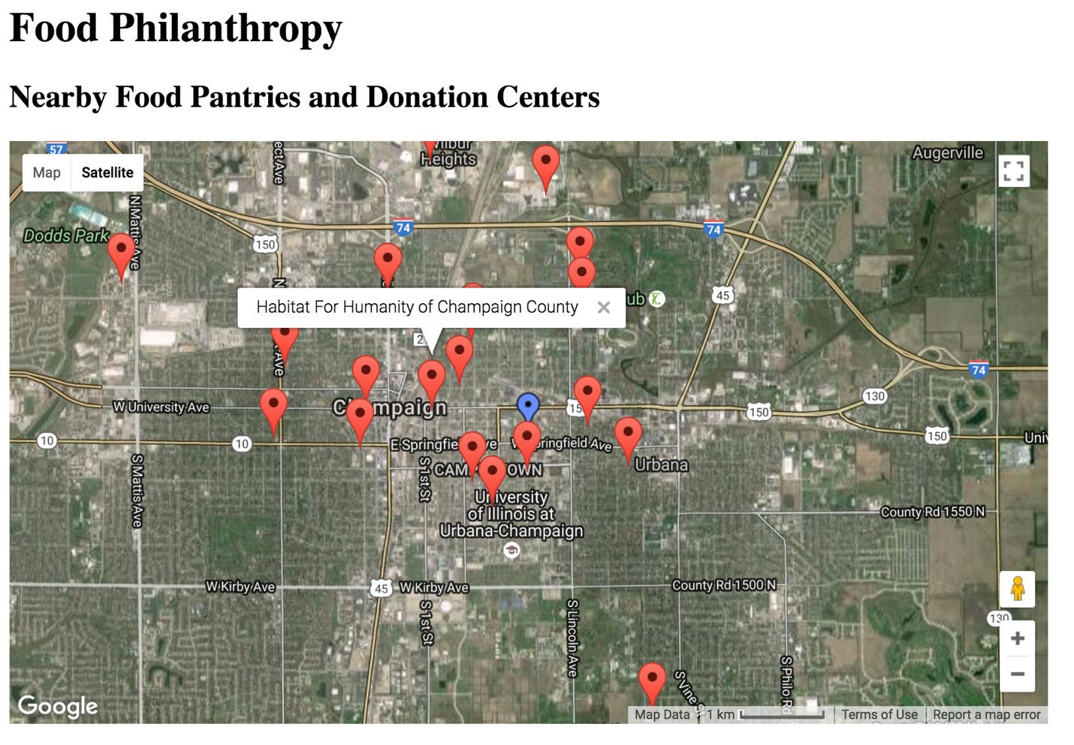

# Full Screen

This is the map made into a full screen of the page in order to have better understanding of how the area is for donations and what is available nearby.

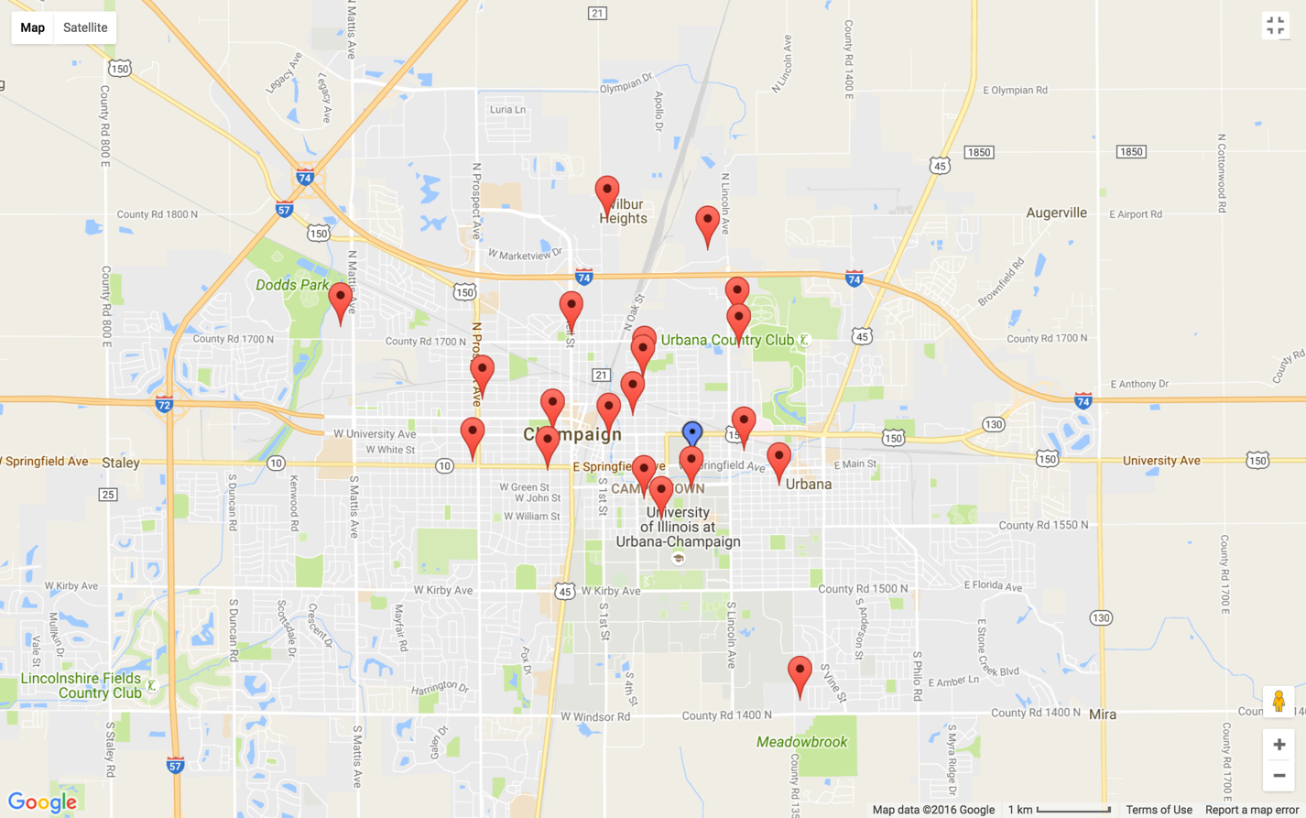

# Current Location

This shows an example of how the current location tab is colored differently and labeled appropriately.

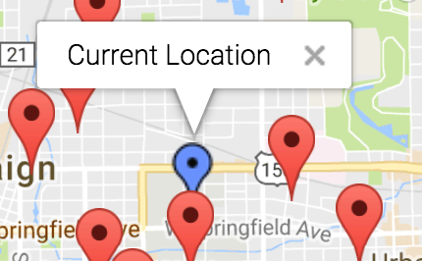

# Pantry Location

This shows how the user can identify different pantries to understand what the pantry options for donation are in the area.

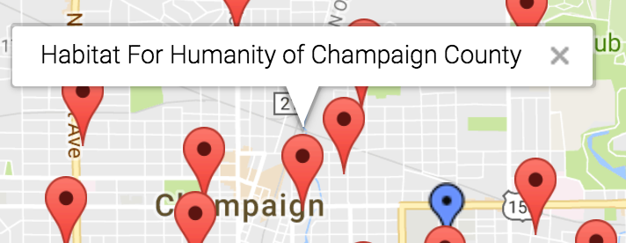

# Street View

This is the map in the street view mode so you can verify locations or get a feel for what type of pantry you will be sending your food too.

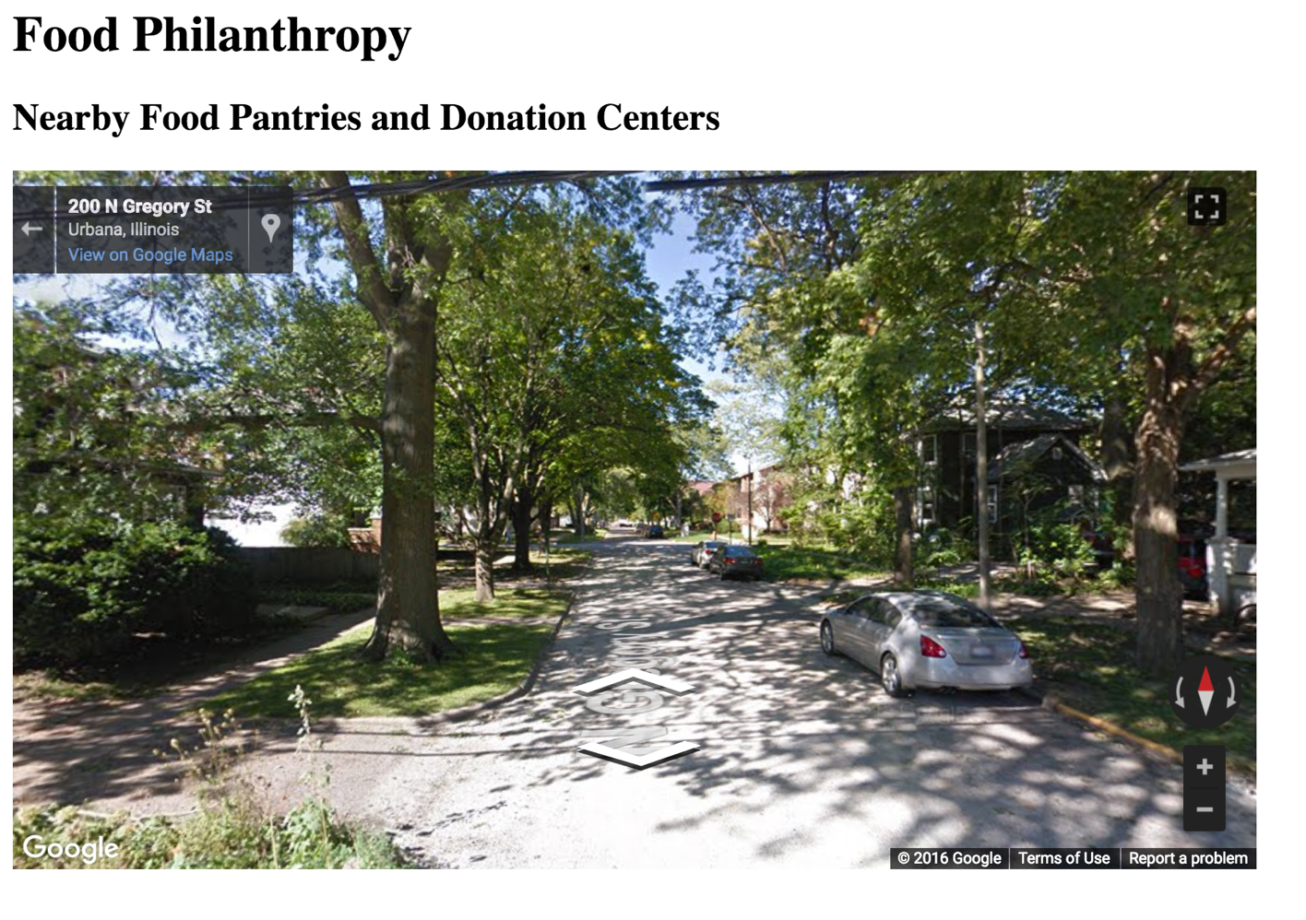

# Pre-Filled Information

Current location information is pre-filled into the form to make it easier for the user if they want to deliver to their location. They can modify this if they want to deliver somewhere else.

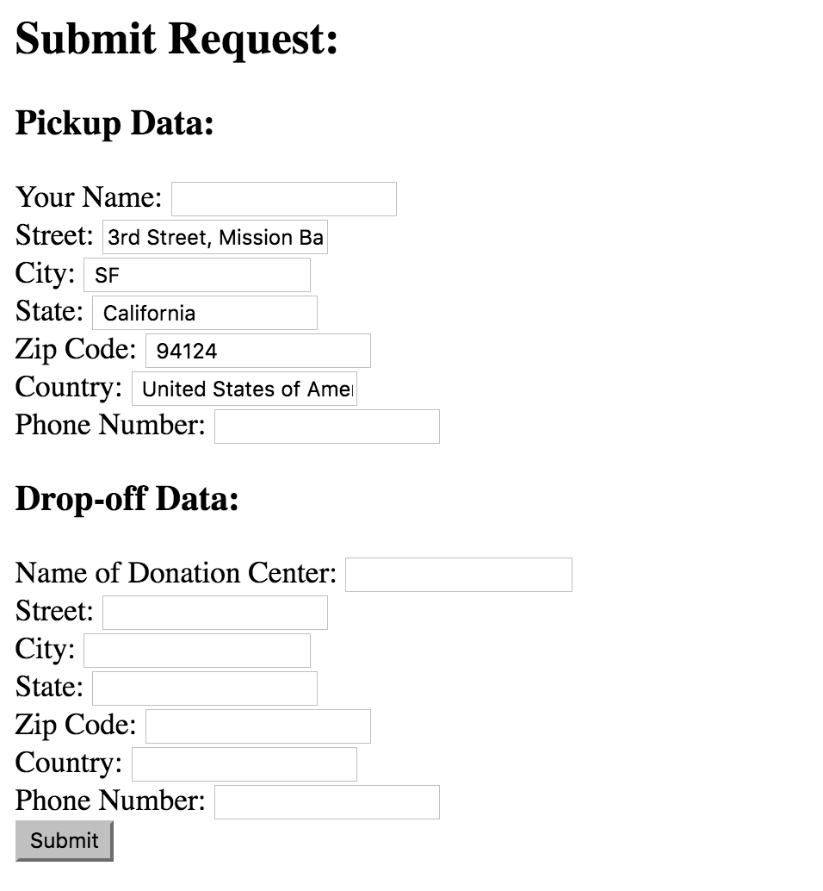

# Auto-Filled Destination

When entering the name of a destination, it auto-fills the information about that destination if it is one of the options available to the user on the map. The image on the left is while entering the name and the image on the right is after it auto-fills.

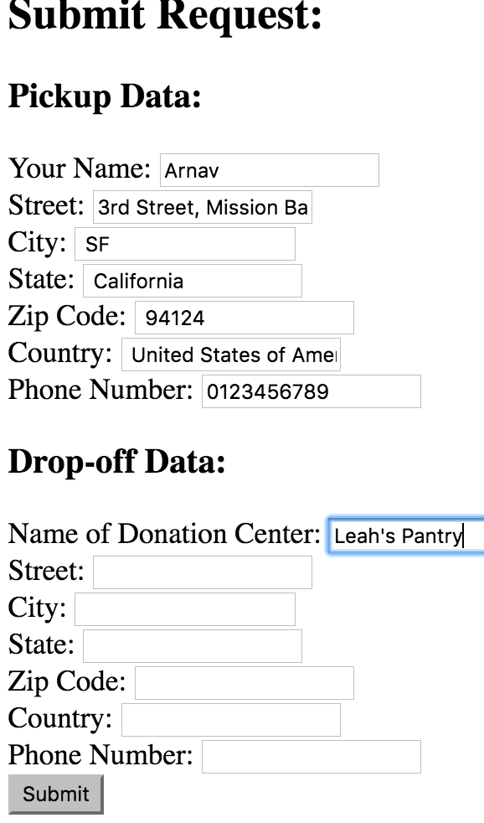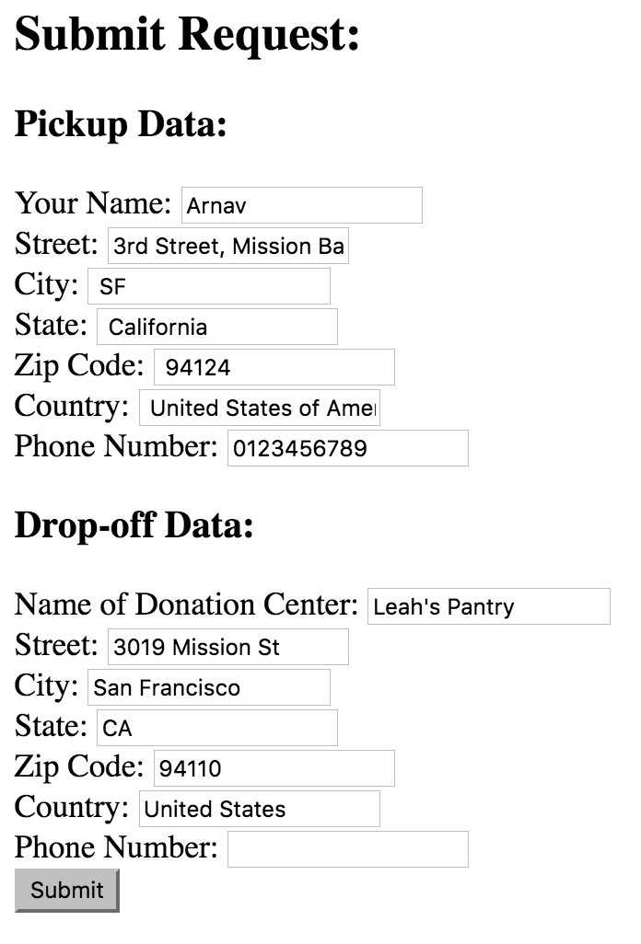

# Route Map

When the route it entered, the ideal route map is developed by Google Maps using the coordinates of each leg of the trip.

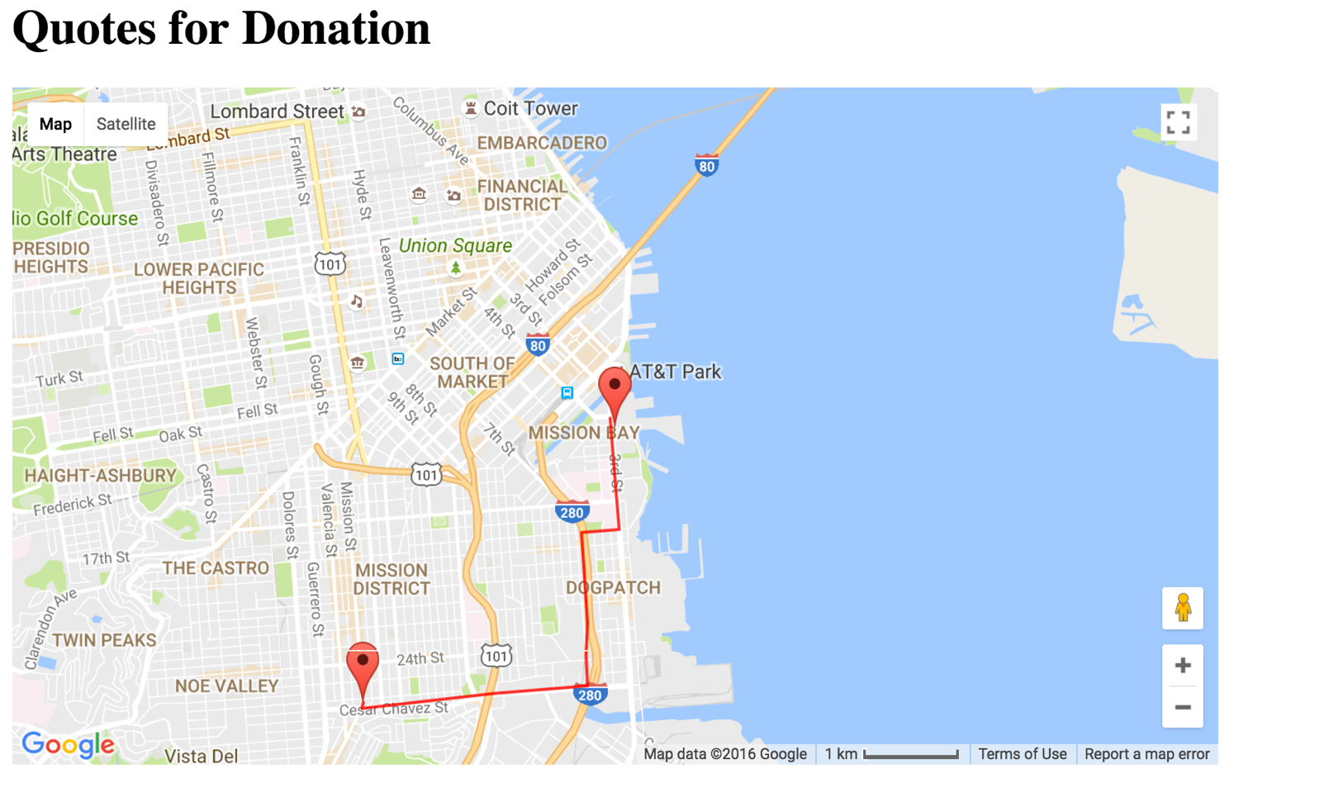

# Quotes

When the route information has been inputted, below the map of the route, a quote is provided for delivery times and costs for both Uber and Postmates. These quotes change based on actual live results as witnessed in the change of the deliver time of Uber in these two identical runs that were just minutes apart:

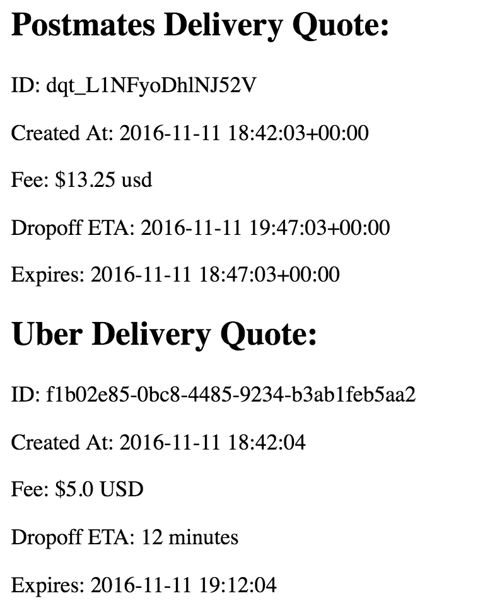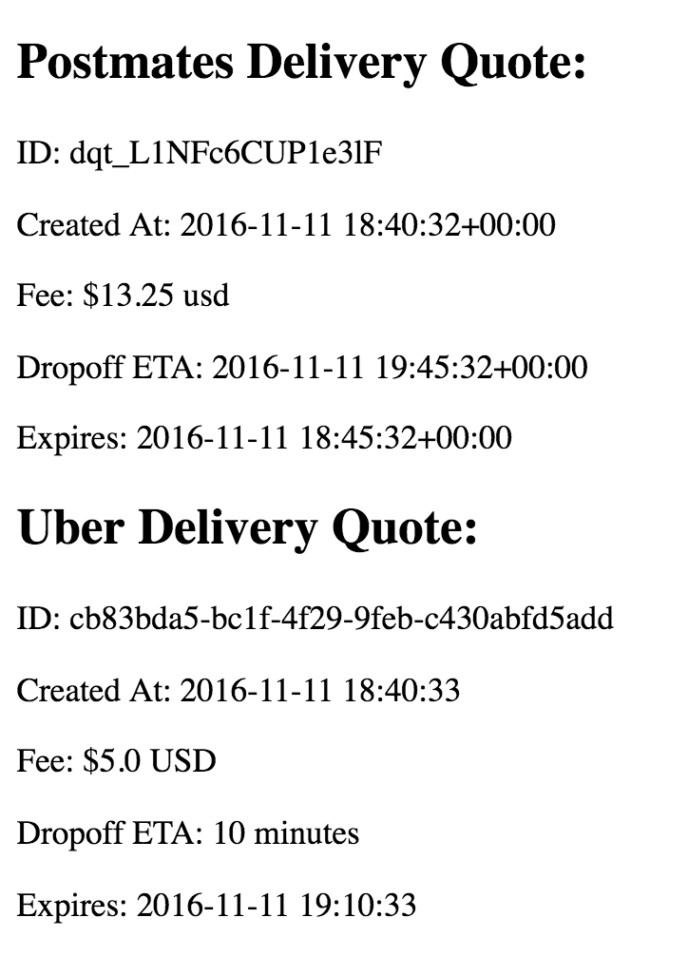

# Auto-Fill Personal Information

All the information about the user is pre-filled based on the information that he/she provides during the initial registration. However, this data is also editable in case something changes.

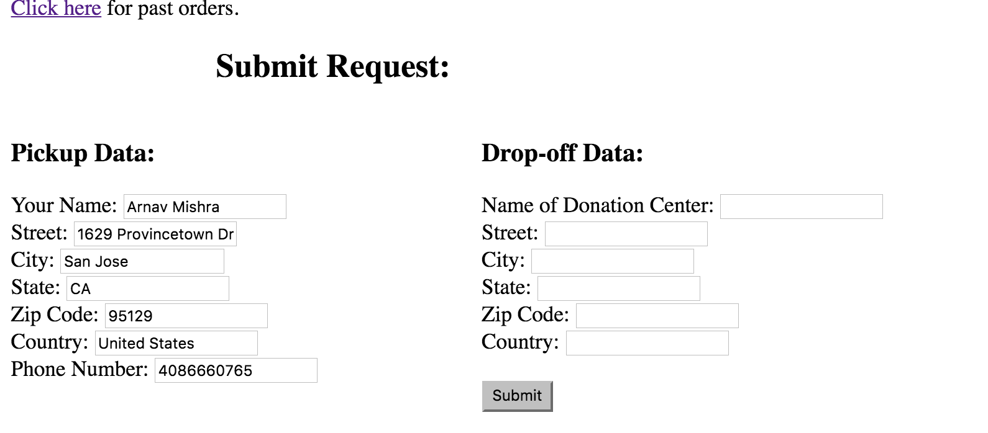

# No Initial Stats

There are no initial stats about any of the users, destinations, deliveries, or states served

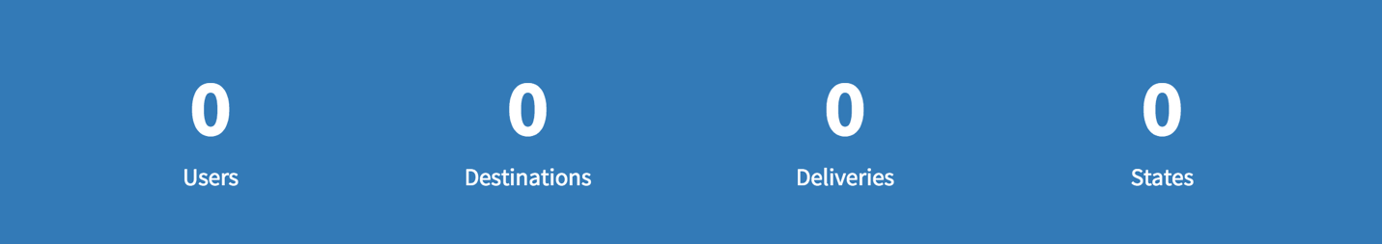

# Added 1 Stat, 2 Stats, 3 Stats

The data updates as more users and stats are added to reflect current global stats.

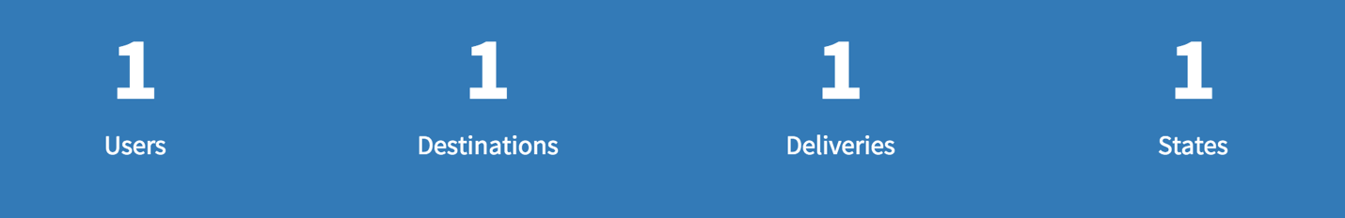



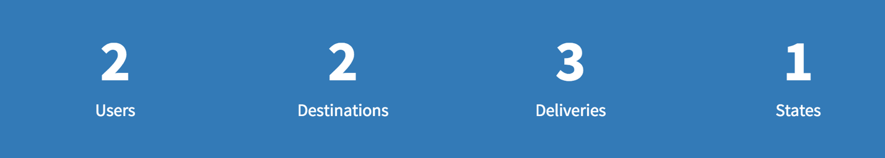

# Past Route Information

The past routes are shown appropriately on the map including metadata about how many times that route has been used and the cheapest and most expensive it has been (including both Uber and Postmates) for each delivery that they have done so far.

